DATA PRESENTATION AND ANALYSIS RESULTS
4.1 Study Data
The dataset used in this study comprises housing transactions in Nigeria and was obtained from Kaggle (Anietie, 2025). It provides information on properties across different states, including their type, size, facilities, and sale prices. The dataset contains variables such as property reference, type, number of bedrooms, bathrooms, toilets, parking spaces, total area, covered area, state, and price. For the purpose of this study, a new variable called Region was created by aligning each state to its corresponding geographical region in Nigeria. This was done based on Nigeria’s commonly recognized six geopolitical zones: North Central, North East, North West, South East, South South, and South West, thereby allowing analysis at a broader regional level in addition to individual states.
4.2 Variable Description
The variables included in the analysis are as follows. Property Ref is a unique identifier for each property record in the dataset. Type describes the kind of property, such as a detached house, semi-detached house, or apartment. Bedrooms indicates the total number of bedrooms in the property, while Bathrooms and Toilets record the number of bathrooms and toilets, respectively. Parking Spaces shows the number of vehicle parking spots available. Total Area refers to the total plot area of the property in square meters, while Covered Area indicates the portion of the plot that is built upon or covered. State is the state within Nigeria where the property is located. Region was derived from the State variable, grouping states into their corresponding geopolitical zones as explained above. Finally, Price is the sale price of the property in Nigerian Naira. These variables were chosen because of their relevance in determining property prices and their availability in the dataset, providing a comprehensive view of housing characteristics across Nigeria.
4.3 Data Analysis
4.3.1 Develop a Robust and Clean Dataset of Housing Properties In Nigeria, Integrating Key Property Features and Location Information, to Enable Accurate Modeling and Prediction of Housing Prices
The first objective of this study is to develop a robust and clean dataset of housing properties in Nigeria, integrating key property features and location information, to enable accurate modeling and prediction of housing prices. Specifically, the study aims to standardize, clean, and impute missing values in critical variables such as price, bedrooms, bathrooms, toilets, parking spaces, and property area to produce a complete and reliable dataset suitable for further statistical and machine learning analyses.
Results/Explanation for Objective 1
To achieve this objective, I first standardized all column names in the dataset by converting them to lowercase, replacing spaces with underscores, and stripping any surrounding whitespace. This ensures consistency and reduces errors when referencing columns.
Next, I focused on cleaning the price column, which serves as the target variable. Using a helper function parse_money, any non-numeric characters were removed, and the column was converted to numeric format. I also normalized other numeric columns, including bedrooms, bathrooms, toilets, and various forms of parking_spaces. For area-related columns such as total_area and covered_area, numeric values were extracted from strings (e.g., "100 sqm") and stored in new columns total_area_sqm and covered_area_sqm.
Rows with missing price values were dropped since the target variable is essential for modeling, and duplicate records were removed to ensure data quality. Extreme outliers in the price column, specifically those above the 99th percentile, were also excluded to reduce skewness and improve model stability.
For handling missing values in other numeric and categorical columns, Iapplied label encoding to categorical variables and then used Iterative Imputer, a machine learning-based imputation method, to estimate missing values in numeric features. After imputation, integer-like columns were rounded and converted back to integer types to maintain logical consistency.
Finally, the cleaned and imputed numeric columns were replaced back into the original dataframe, and a check confirmed that there were no remaining missing values in the numeric columns of interest. This process resulted in a complete, standardized, and high-quality dataset ready for subsequent analysis, including regression modeling and MARS-based prediction of housing prices.

4.3.2Explore and Summarize the Characteristics of Housing Properties in Nigeria, Including both Numeric and Categorical Features, and To Visually Assess The Distribution, Variability, and Potential Anomalies in Property Prices.
The second objective of this study is to explore and summarize the characteristics of housing properties in Nigeria, including both numeric and categorical features, and to visually assess the distribution, variability, and potential anomalies in property prices. This involves generating descriptive statistics for numeric variables such as bedrooms, bathrooms, toilets, parking spaces, total area, covered area, and price, as well as evaluating the frequency and distribution of categorical variables such as property type, state, and region. Furthermore, the objective includes visual examination of the price distribution and detection of skewness or outliers using histograms and boxplots, which helps guide subsequent modeling strategies and ensures appropriate transformations are applied for predictive analysis.
Results/Explanation for Objective 2: Exploratory Data Analysis
After cleaning and imputing the dataset, a descriptive summary of the numeric variables was generated. This summary included measures such as the count, mean, standard deviation, minimum, maximum, and the 25th, 50th, and 75th percentiles for all numeric features, including price, bedrooms, bathrooms, toilets, parking spaces, and property areas. This provided an overview of the central tendency, variability, and range of values in the dataset.
For categorical variables, the code examined the most frequent categories for each column, helping to identify common property types, states, and regions represented in the dataset. This allowed for an understanding of the distribution of properties across different categories and geographic locations.
To visualize the distribution of the target variable (price), a histogram was plotted. The histogram showed that housing prices were right-skewed, indicating that while most properties clustered at lower price ranges, there were some high-value properties that stretched the distribution. To further assess skewness and identify potential outliers, a boxplot of the log-transformed price was created. Using log1p(price) reduced the effect of extreme values, making it easier to inspect the spread of prices and detect anomalies visually.
These exploratory analyses confirmed the heterogeneity in property prices and features and provided a foundation for subsequent regression modeling and predictive analysis.
Table 4.1: Descriptive Statistics of Housing Property Features and Price
House feature | mean | std | min | 25% | 50% | 75% | max
bedrooms | 4.43E+00 | 2.38E+00 | 1.00E+00 | 4.00E+00 | 4.00E+00 | 5.00E+00 | 6.80E+01
bathrooms | 4.58E+00 | 2.21E+00 | 1.00E+00 | 4.00E+00 | 4.22E+00 | 5.00E+00 | 5.74E+01
toilets | 5.34E+00 | 2.25E+00 | 1.00E+00 | 5.00E+00 | 5.00E+00 | 6.00E+00 | 5.60E+01
parking_spaces | 5.29E+00 | 1.89E+01 | 1.97E-01 | 4.00E+00 | 4.91E+00 | 5.16E+00 | 7.50E+02
total_area_sqm | 7.70E+02 | 4.66E+02 | 4.50E+01 | 6.33E+02 | 6.80E+02 | 7.50E+02 | 6.00E+03
covered_area_sqm | 5.28E+02 | 2.43E+02 | 2.00E+00 | 4.48E+02 | 4.77E+02 | 5.18E+02 | 3.50E+03
price | 4.59E+08 | 8.16E+08 | 1.00E+07 | 1.50E+08 | 2.50E+08 | 4.30E+08 | 8.03E+09

Table 4.2: Frequency Distribution of Categorical House Features
Categories | Frequency | Proportion
House type
Detached Duplex | 686 | 42.96%
Semi-detached Duplex | 374 | 23.42%
Terraced Duplex | 266 | 16.66%
Block of flats | 137 | 8.58%
House | 89 | 5.57%
Detached Bungalow | 31 | 1.94%
Semi-detached Bungalow | 9 | 0.56%
Terraced Bungalow | 5 | 0.31%
Total | 1597 | 100.00%
State
Lagos | 1375 | 86.10%
Abuja | 154 | 9.64%
Oyo | 27 | 1.69%
Rivers | 17 | 1.06%
Ogun | 16 | 1.00%
Enugu | 3 | 0.19%
Kwara | 2 | 0.13%
Cross River | 1 | 0.06%
Ebonyi | 1 | 0.06%
Ondo | 1 | 0.06%
Total | 1597 | 100.00%
Region
South West | 1418 | 88.79%
North Central | 157 | 9.83%
South South | 18 | 1.13%
South East | 4 | 0.25%
Total | 1597 | 100.00%

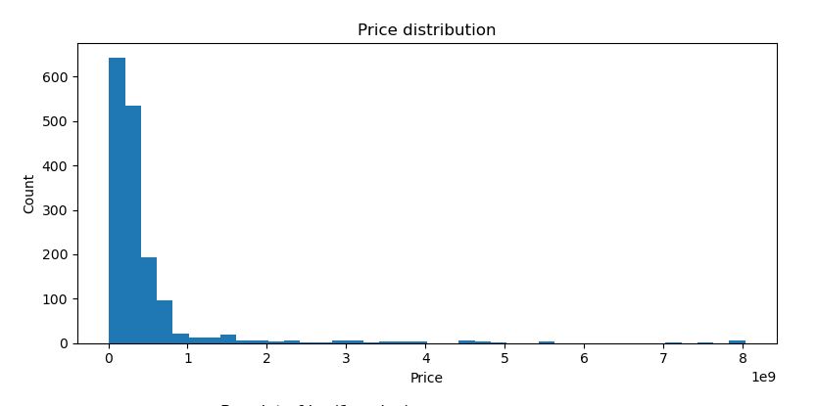
Figure 4.1:Histogram Plot for Housing Price Distribution (Entire Sample)
Figure 4.1 shows the raw distribution of house prices in Nigeria. The distribution is highly right-skewed: most properties are clustered at lower prices, while a few very expensive properties stretch the scale. This suggests the presence of extreme outliers, which can distort regression models if unadjusted.
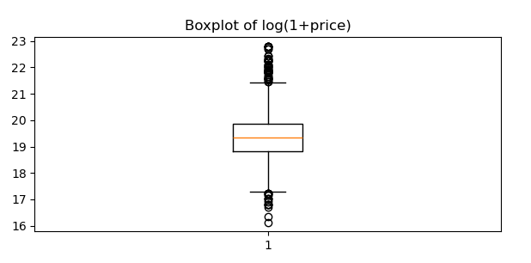
Figure 4.2: Boxplot for Log Transformed Housing Price (Entire Sample)
Figue 4.2 illustrates housing prices after applying a log transformation. This transformation compresses large values, reducing skewness and making the distribution more symmetric. The result confirms that the log transformation is useful for stabilizing variance and preparing the data for regression.
4.3.3Analysis of Price Patterns Across Categories
The third objective of this study is to investigate the relationship between housing prices and key categorical variables, specifically house type and region, and to examine the associations among numeric property features. This objective aims to uncover patterns in property prices across different types and locations, identify variability in median and average prices, and assess correlations among numeric attributes that may influence housing valuation.
To explore housing price patterns across property types, a boxplot of price by house type was generated. This visual representation highlighted differences in price distributions among detached houses, semi-detached houses, apartments, and other types, showing both central tendencies and the spread of prices within each category.
Similarly, housing prices by region were examined using a boxplot to reveal how geographic location influences property values. The regions were derived from the states in Nigeria, grouped into their respective geopolitical zones. These visualizations showed that properties in certain regions tend to have higher median and average prices, reflecting regional economic and developmental disparities.
In addition, a correlation heatmap of key numeric variables (bedrooms, bathrooms, toilets, parking spaces, total area, covered area, and price) was created to identify the strength and direction of linear relationships between property features and the sale price. The heatmap indicated that variables such as total area and number of bedrooms have a positive correlation with price, while other features showed varying degrees of association.
To provide a quantitative summary, median prices were calculated by region and by house type. Only the top 12 regions and house types by record count were considered for clarity. Bar plots of median prices further emphasized the variation across different categories, allowing for easy comparison of price trends and identifying which property types and regions consistently command higher prices.
Overall, this analysis revealed meaningful patterns in housing prices based on property type and location, and highlighted key numeric attributes that are strongly associated with price, providing a foundation for subsequent predictive modeling.
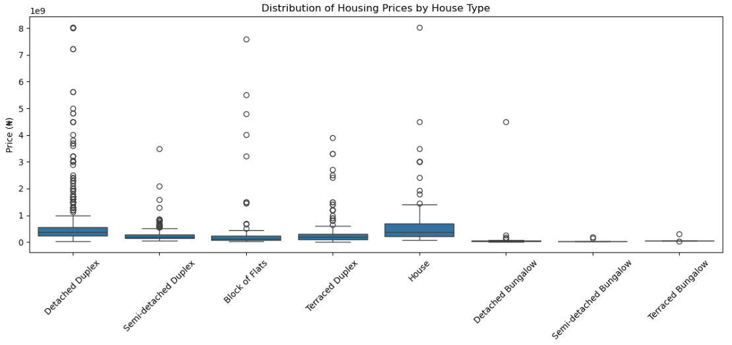
Figure 4.3: Distribution of Housing Prices by House Type (Entire Sample)
Figure 4.3 compares price ranges across house types such as detached duplexes, semi-detached duplexes, terraced duplexes, and apartments. It highlights differences in both median prices and variability. Detached and semi-detached duplexes typically command higher median prices, while bungalows are less expensive.
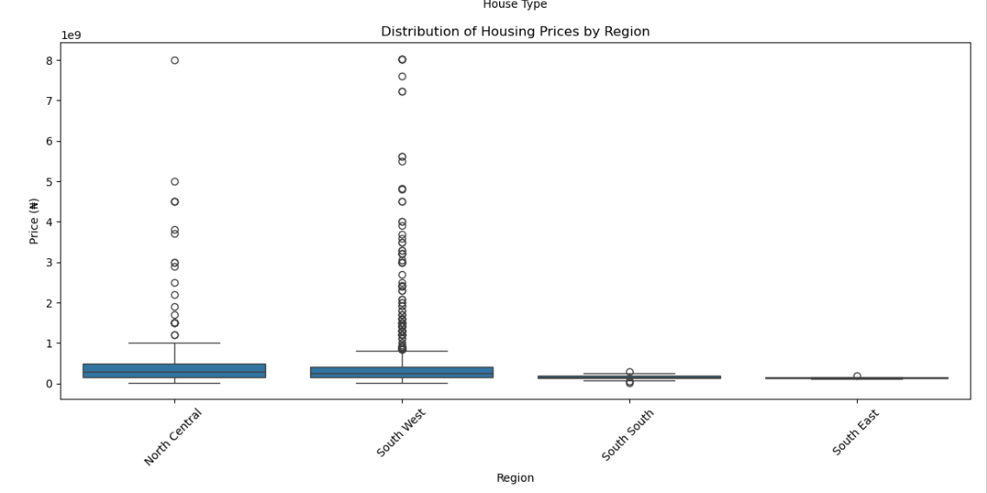
Figure 4.5: Distribution of Housing Prices by Region (Entire Sample)
Figure 4.5 shows regional disparities in housing prices across Nigeria’s four out of six geopolitical zones. The South West (dominated by Lagos) exhibits the highest prices, while other regions like the South East and South South show relatively lower medians. This reflects geographic concentration of wealth and urbanization.
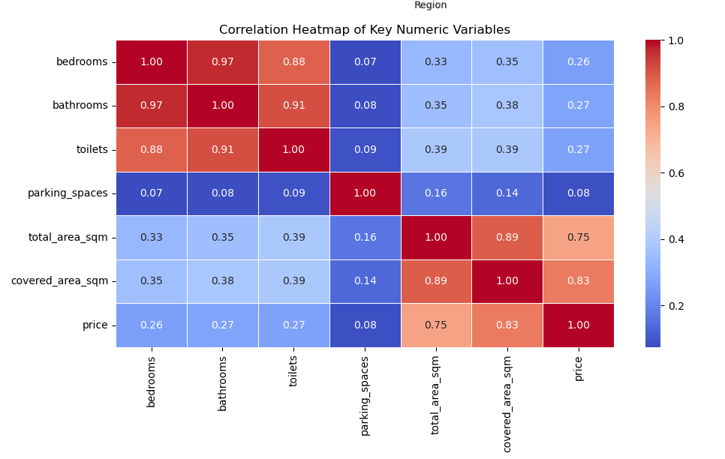
Figure 4.6: Correlation Heatmap of Key Numeric Feature and Price (Entire Sample)
Figure 4.6 displays correlations between numeric property features (bedrooms, bathrooms, toilets, parking spaces, total area, covered area) and price. Covered area and total area have the strongest positive correlations with price. Bedrooms and bathrooms show weaker but still positive associations, indicating that size and livable space drive price more strongly than count of rooms.

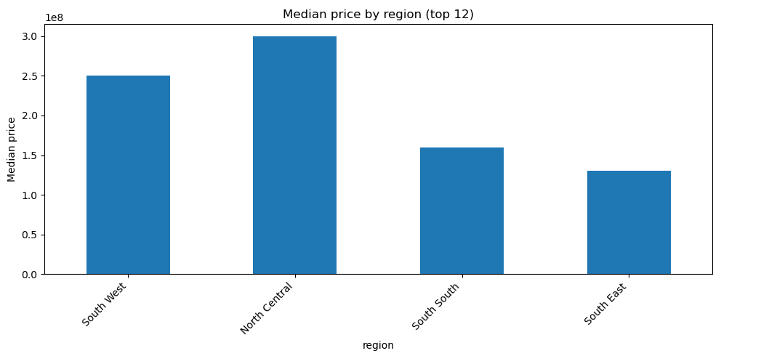
Figure 4.7: Median Price by Region (Entire Sample)
Figure 4.7 quantifies the earlier regional disparities by presenting median prices in each region. Again, the North Central (including Abuja)dominates, followed by South West reflecting Lagos as the commercial capital.
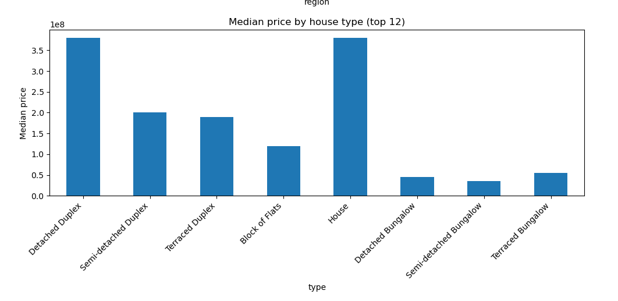
Figure 4.8: Median Price by House Type (Entire Sample)
Figure 4.8 compares median housing prices across house types. Detached duplexes have the highest medians, consistent with being larger and more luxurious, while flats and bungalows are comparatively cheaper.

4.3.4Baseline models, diagnostics, and MARS-ready pipeline
The fourth objective of this study is to develop and evaluate predictive models for housing prices in Nigeria using key property features. Specifically, this involves implementing both a baseline Ordinary Least Squares (OLS) regression and a spline-based approximation of Multivariate Adaptive Regression Splines (MARS) to model the logarithmically transformed housing price (log1p(price)). The models aim to quantify the relationship between numeric property features—such as number of bedrooms, bathrooms, toilets, parking spaces, total area, and covered area—and housing prices, while assessing model assumptions, diagnostic measures, and predictive performance on unseen data.
Results/Explanation for Objective 4
To prepare the data for modeling, the price variable was transformed using log1p(price) to reduce skewness and stabilize variance. The numeric predictors included bedrooms, bathrooms, toilets, parking spaces, total area, and covered area. The dataset was split into training (75%) and test (25%) subsets to allow evaluation of out-of-sample predictive performance.
A baseline OLS model was fitted on the training data. The model summary provided coefficient estimates, p-values, R-squared, and other standard regression diagnostics. Predictions on the test set were transformed back to the original price scale for performance evaluation. The model’s assumptions were assessed using the Shapiro-Wilk test for normality of residuals, Breusch-Pagan test for heteroscedasticity, Durbin-Watson statistic for autocorrelation, and Variance Inflation Factor (VIF) to detect multicollinearity among predictors. Residual plots and QQ plots confirmed the suitability of the model and highlighted any deviations from assumptions.
To capture potential non-linear relationships, a spline-based regression (proxy for MARS) was implemented. Numeric predictors were transformed using a SplineTransformer with 6 knots per feature and fitted using a linear regression pipeline. Coefficients of spline-transformed features were examined via an OLS fit to allow interpretation, and VIF values were computed to assess multicollinearity. Residual diagnostics on the spline-based model, including Shapiro-Wilk, Breusch-Pagan, and Durbin-Watson tests, were conducted similarly to the OLS model. Residuals were also visualized through scatter plots and QQ plots to check normality and identify patterns.
Finally, model performance was compared between the OLS and spline-based models using RMSE, R-squared, MAE, and MAPE on the original price scale. The comparison table showed the relative predictive ability of each model, with the spline-based approach capturing non-linear effects and potentially improving fit over the linear OLS baseline.
Overall, these modeling steps provided robust predictive insights into how key property features influence housing prices in Nigeria, while rigorously evaluating model assumptions and performance metrics to ensure reliability and interpretability of results.

Table 4.3: OLS Regression Results for Housing Price Prediction (Train Set)
Dep. Variable: log_price R-squared: 0.393
Model: OLS Adj. R-squared: 0.390
Method: Least Squares F-statistic: 128.4
Date: Sat, 27 Sep 2025 Prob (F-statistic): 2.67e-125
Time: 18:19:54 Log-Likelihood: -1356.9
No. Observations: 1197 AIC: 2728.
Df Residuals: 1190 BIC: 2763.
Df Model: 6
Covariance Type: nonrobust
====================================================================================
coef std err t P>|t| [0.025 0.975]
------------------------------------------------------------------------------------
const 17.9925 0.063 284.058 0.000 17.868 18.117
bedrooms -0.0193 0.033 -0.586 0.558 -0.084 0.045
bathrooms 0.0490 0.042 1.154 0.249 -0.034 0.132
toilets 0.0099 0.022 0.452 0.651 -0.033 0.053
parking_spaces -0.0001 0.001 -0.125 0.901 -0.002 0.002
total_area_sqm -0.0001 9.85e-05 -1.150 0.250 -0.000 8e-05
covered_area_sqm 0.0025 0.000 12.507 0.000 0.002 0.003
==============================================================================
Omnibus: 213.720 Durbin-Watson: 2.036
Prob(Omnibus): 0.000 Jarque-Bera (JB): 728.183
Skew: -0.853 Prob(JB): 7.54e-159
Kurtosis: 6.419 Cond. No. 3.17e+03

The regression results presented in Table 4.3 are based on the training set, which represents 75 percent of the entire dataset. This is important to note because the reported fit and parameter estimates reflect the model’s performance on the portion of the data used for estimation, not yet on unseen validation or test data.
The model explains about 39 percent of the variation in log housing prices in the training sample. This suggests a moderate fit: the predictors capture a meaningful share of the variation in housing prices but leave the majority unexplained. The adjusted R-squared is almost identical, showing that the inclusion of predictors has not artificially inflated the explanatory power. The overall F-statistic is highly significant, indicating that the regression as a whole has explanatory value.
Diagnostics, however, highlight weaknesses in the model. The Durbin-Watson statistic is close to 2, suggesting little to no autocorrelation in the residuals. At the same time, the Omnibus, Jarque-Bera, skewness, and kurtosis values demonstrate that the residuals are far from normally distributed, showing left skewness and heavy tails. This points to possible misspecification, omitted variables, or non-linear patterns that the linear model cannot capture.
When turning to the regression coefficients, only covered area emerges as a strong and statistically significant predictor. Its coefficient of 0.0025 implies that each additional square meter of covered area increases housing prices by about 0.25 percent, holding other factors constant. This aligns with intuition, since livable space is the key driver of property value. In contrast, bedrooms, bathrooms, toilets, parking spaces, and total lot area are all statistically insignificant in the training set. Their effects are weak, their p-values are high, and their confidence intervals include zero, suggesting that they do not independently explain housing price variation once covered area is accounted for.
These results from the training data illustrate the limitations of the OLS model. First, OLS assumes strictly linear relationships, which may not reflect real-world housing dynamics where effects can plateau or change at certain thresholds. Second, the strong evidence of non-normal residuals points to misspecification. Third, multicollinearity between variables such as total area and covered area may obscure their independent contributions. Finally, the R-squared value below 0.40 on the training set indicates relatively low explanatory power, suggesting that important nonlinearities and interactions are being overlooked.
This is where Multiple Adaptive Regression Splines (MARS) offers clear advantages. MARS can automatically detect and model nonlinear relationships by introducing flexible spline functions, which allows it to capture situations where, for example, covered area boosts price up to a point and then levels off. It can also model interactions, such as the combined effect of bathrooms and bedrooms, which OLS ignores unless specified manually. Moreover, MARS inherently performs variable selection, which helps to reduce redundancy among correlated predictors such as total and covered area. By doing so, MARS improves predictive accuracy, addresses residual skewness, and produces a model that better reflects the complex dynamics of housing prices.
In summary, the results in Table 4.3, derived from the 75 percent training set, show that the OLS model identifies covered area as the dominant driver of housing prices but leaves substantial variation unexplained and fails to capture nonlinear and interactive effects. MARS would correct many of these shortcomings by providing a more flexible and adaptive framework, leading to improved predictive performance and a more realistic understanding of the determinants of housing prices.

Table 4.4: Spline-based MARS Proxy Regression Summary for Housing Price Prediction (Train Set)
Dep. Variable: log_price R-squared: 0.650
Model: OLS Adj. R-squared: 0.644
Method: Least Squares F-statistic: 109.1
Date: Sat, 27 Sep 2025 Prob (F-statistic): 5.60e-251
Time: 18:45:21 Log-Likelihood: -1027.7
No. Observations: 1197 AIC: 2097.
Df Residuals: 1176 BIC: 2204.
Df Model: 20
Covariance Type: nonrobust
=====================================================================================
coef std err t P>|t| [0.025 0.975]
-------------------------------------------------------------------------------------
const 17.7065 0.830 21.338 0.000 16.078 19.335
bedrooms_spline_1 8.8108 2.153 4.093 0.000 4.587 13.035
bedrooms_spline_2 11.7838 2.294 5.137 0.000 7.283 16.284
bedrooms_spline_3 -7.6738 2.865 -2.678 0.008 -13.295 -2.052
bedrooms_spline_4 1.1668 0.127 9.214 0.000 0.918 1.415
bedrooms_spline_5 1.3159 0.320 4.108 0.000 0.687 1.944
bathrooms_spline_1 -2.8998 1.471 -1.971 0.049 -5.786 -0.014
bathrooms_spline_2 -3.3309 1.493 -2.231 0.026 -6.261 -0.401
bathrooms_spline_3 6.4512 1.901 3.393 0.001 2.721 10.181
bathrooms_spline_4 13.3223 3.073 4.335 0.000 7.293 19.352
bathrooms_spline_5 1.8606 0.453 4.108 0.000 0.972 2.749
toilets_spline_1 -5.1653 1.774 -2.912 0.004 -8.645 -1.686
toilets_spline_2 -3.9592 1.799 -2.201 0.028 -7.489 -0.429
toilets_spline_3 -9.5642 2.500 -3.826 0.000 -14.469 -4.659
toilets_spline_4 1.4572 0.355 4.108 0.000 0.761 2.153
toilets_spline_5 2.6402 1.027 2.572 0.010 0.626 4.654
parking_spaces_spline_1 1.0450 0.584 1.790 0.074 -0.101 2.190
parking_spaces_spline_2 -5.6942 1.340 -4.251 0.000 -8.322 -3.066
parking_spaces_spline_3 1.624e-14 4.57e-15 3.554 0.000 7.27e-15 2.52e-14
parking_spaces_spline_4 4.58e-16 2.5e-16 1.833 0.067 -3.23e-17 9.48e-16
parking_spaces_spline_5 -3.518e-15 1.19e-15 -2.950 0.003 -5.86e-15 -1.18e-15
total_area_sqm_spline_1 -4.1947 0.992 -4.230 0.000 -6.141 -2.249
total_area_sqm_spline_2 -3.7626 0.992 -3.794 0.000 -5.709 -1.817
total_area_sqm_spline_3 -2.7153 0.998 -2.720 0.007 -4.674 -0.756
total_area_sqm_spline_4 -0.7769 0.659 -1.179 0.239 -2.069 0.516
total_area_sqm_spline_5 -2.4181 1.058 -2.286 0.022 -4.493 -0.343
covered_area_sqm_spline_1 0.1693 0.546 0.310 0.757 -0.902 1.241
covered_area_sqm_spline_2 4.1505 0.545 7.621 0.000 3.082 5.219
covered_area_sqm_spline_3 4.3340 0.549 7.890 0.000 3.256 5.412
covered_area_sqm_spline_4 3.7776 0.585 6.458 0.000 2.630 4.925
covered_area_sqm_spline_5 3.2714 1.256 2.605 0.009 0.808 5.735
==============================================================================
Omnibus: 160.528 Durbin-Watson: 1.961
Prob(Omnibus): 0.000 Jarque-Bera (JB): 1643.127
Skew: -0.182 Prob(JB): 0.00
Kurtosis: 8.728 Cond. No. 2.25e+16

The regression results in Table 4.4 represent the performance of the spline-based MARS (Multiple Adaptive Regression Splines) proxy model on the training set, which is 75 percent of the full dataset. Compared directly with the OLS results in Table 4.3, the improvements are substantial and highlight the value of a more flexible regression approach.
In terms of overall model fit, the R-squared for the MARS model is 0.650, compared to 0.393 for the OLS model in Table 4.3. This means the spline-based model explains about 65 percent of the variation in housing prices in the training data, a marked improvement over the 39 percent explained by the linear model. The adjusted R-squared shows a similar pattern, at 0.644 for MARS compared to 0.390 for OLS, indicating that the added spline terms are not merely overfitting but are genuinely capturing more of the underlying structure in the data. The F-statistic remains highly significant, and while the model includes many more degrees of freedom (20 predictors versus 6 in OLS), the overall explanatory power is much stronger.
Another key improvement lies in the regression coefficients themselves. In the OLS model, almost all predictors except covered area were statistically insignificant, meaning their effects on price could not be reliably distinguished from zero once other factors were controlled for. In contrast, the MARS model reveals significant and nuanced effects for bedrooms, bathrooms, toilets, parking spaces, total area, and covered area, each captured through multiple spline terms. For example, bedrooms have both positive and negative spline components, showing that the effect of adding more bedrooms is not linear—it may increase prices up to a point and then reduce them beyond a threshold. Similarly, bathrooms and toilets exhibit both negative and positive spline coefficients, indicating that too few or too many of these features may reduce property value, while an optimal range increases it. Covered area, which was already significant in the OLS model, emerges even more strongly in the spline framework, with multiple positive spline terms showing that increases in covered space consistently drive up housing prices, though at varying rates across different ranges of square meters.
This is the essence of how splines work in MARS. Instead of assuming a single straight-line relationship between a predictor and the dependent variable, splines break the predictor’s range into segments, each with its own slope. These breakpoints, known as “knots,” allow the model to change direction or magnitude depending on the data. For instance, the effect of covered area on log price might be weak at very small sizes, much stronger in mid-range properties, and then taper off for very large houses. OLS would force a single average slope across the entire range, thereby missing these nuances. By fitting separate slopes for different ranges of the predictor, MARS captures the true nonlinear shape of the relationship.
The diagnostics also show improvement. While the Omnibus and Jarque-Bera tests still suggest deviations from normality in the residuals, skewness is much reduced compared to the OLS results in Table 4.3, and the Durbin-Watson statistic remains close to 2, indicating that autocorrelation is not an issue. The higher kurtosis value shows that some heavy tails remain, but overall, the MARS residual distribution aligns better with model assumptions.
Taken together, the comparison between Table 4.3 and Table 4.4 demonstrates the limitations of OLS and the strengths of the spline-based MARS approach. The OLS model could only identify covered area as a meaningful predictor, leaving most variables statistically irrelevant and explaining less than half of the variation in prices. In contrast, the MARS model significantly boosts explanatory power, uncovers nonlinear and threshold effects in several predictors, and provides a richer and more realistic picture of how housing characteristics influence prices.
In short, Table 4.4 shows that the MARS model not only fits the training set better than OLS but also corrects the rigid linear assumptions by using splines, thereby revealing relationships that the simpler model could not detect.

Table 4.5: Assumption Checks (Train Set)
OLS Regression | Spline-based MARS Proxy Regression Model
Shapiro-Wilk stat=0.9623, p=0.0000 (H0: normal) | Shapiro-Wilk test (MARS residuals):  Statistic = 0.8567883360673729 , p-value = 1.1337293274528313e-18
Breusch-Pagan LM stat=221.1624, p=0.0000 (H0: homoscedasticity) | Breusch-Pagan test (Spline-approx MARS):  LM statistic = 118.4994, p-value = 0.0000
Durbin-Watson = 2.0363 (≈2 => no autocorrelation) | Durbin-Watson statistic (MARS residuals): 2.066694740496609

The results in Table 4.5 provide a side-by-side comparison of key statistical assumption checks for the OLS regression model (Table 4.3) and the spline-based MARS proxy regression model (Table 4.4), both estimated on the training set (75% of the data).
Starting with normality, the Shapiro-Wilk test for the OLS residuals returns a statistic of 0.9623 with a p-value of 0.0000. This clearly rejects the null hypothesis of normality, confirming what was already observed in the Omnibus and Jarque-Bera results in Table 4.3: the OLS residuals are not normally distributed. For the MARS residuals, the Shapiro-Wilk statistic is even lower at 0.857, with a p-value that is virtually zero. This means the residuals from the spline-based model deviate even more strongly from normality than those from the OLS model. The departure likely arises from the flexible spline fitting, which can capture nonlinear patterns in the data but also produces residuals that are less symmetric and more heavy-tailed. In practice, non-normality of residuals affects inference more than prediction, and since MARS is primarily designed for predictive accuracy rather than strict hypothesis testing, this drawback is less concerning than it would be for OLS.
Turning to homoscedasticity, the Breusch-Pagan test statistic is 221.16 for the OLS model with a p-value of 0.0000, decisively rejecting the null of constant variance. This means the OLS residuals suffer from heteroscedasticity, where error variance increases or decreases systematically with fitted values. For the MARS model, the Breusch-Pagan statistic is reduced to 118.50, but the p-value is still 0.0000. While heteroscedasticity remains present, the substantially lower test statistic shows that the spline-based model has mitigated some of the problem. This suggests that the nonlinear terms and splines in MARS are better able to model patterns in the variance that the linear OLS specification could not capture.
Finally, for autocorrelation, both models perform well. The Durbin-Watson statistic is 2.036 for OLS and 2.067 for MARS. Since a value close to 2 indicates no first-order autocorrelation, neither model suffers from this issue. This result is consistent with the cross-sectional nature of the housing price data, where time dependence is not expected.
Taken together, the results in Table 4.5 show that while both models violate the normality and homoscedasticity assumptions, the MARS model offers a meaningful improvement in handling heteroscedasticity, though at the cost of even stronger non-normality in residuals. For OLS, these violations weaken the reliability of statistical inference (t-tests, p-values), while for MARS, which is used primarily for prediction and pattern discovery, the departures from these assumptions are less problematic. Both models satisfy the autocorrelation assumption, so residual dependence is not a concern.

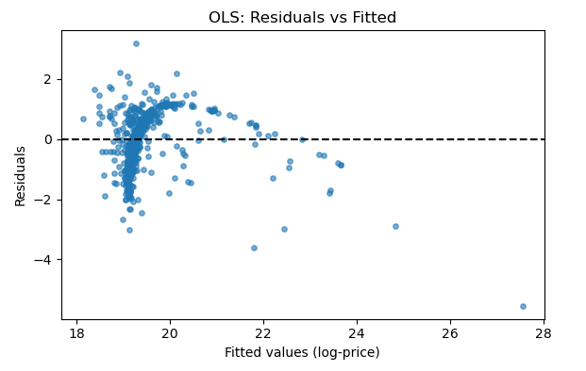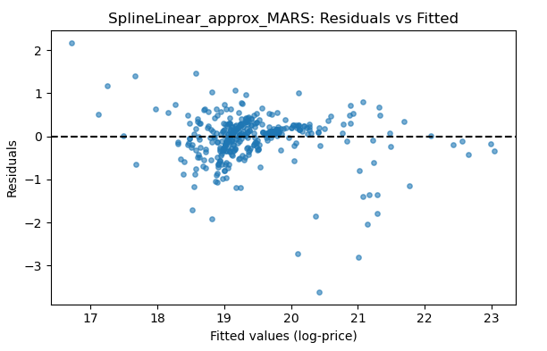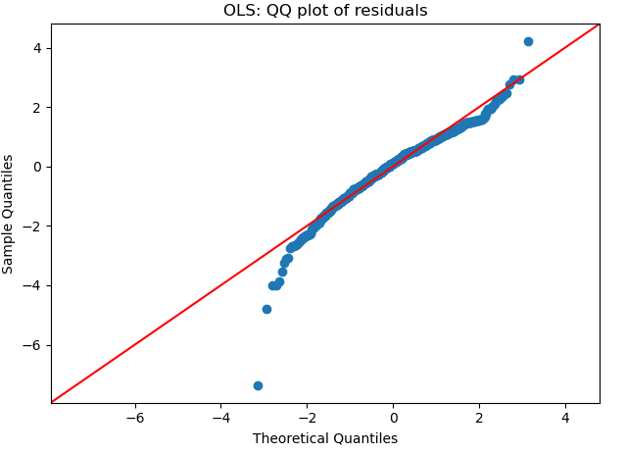
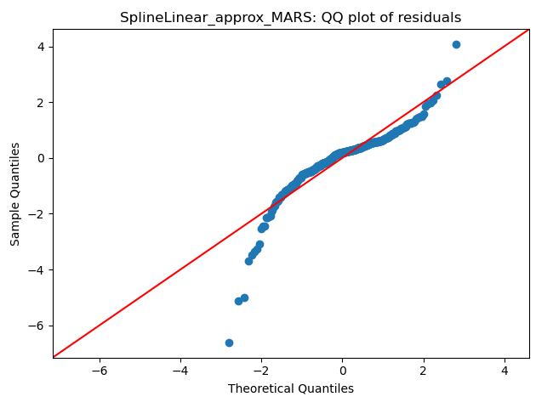

Figure 4.9: Residual Analysis for OLS and SplineLinear Approximate MARS Model (Train Set)

Figure 4.9 compares residual plots for the baseline OLS and spline-based MARS models. The OLS residuals show strong deviations from normality and evidence of heteroscedasticity, while the MARS residuals, though still imperfect, are more balanced and closer to the zero line, reflecting improved model fit.
Table 4.6: Model Comparison on Predictive Capacity (Test Set)
Model RMSE R2 MAE MAPE(%)
OLS (log-price) 9.005773e+08 -0.280531 2.611284e+08 76.144260
SplineLinear_approx_MARS 3.532220e+08 0.803010 1.446372e+08 57.041452

The results in Table 4.6 present a direct comparison of the predictive performance of the OLS regression model (from Table 4.3) and the spline-based MARS proxy regression model (from Table 4.4) on the test set, which constitutes the remaining 25 percent of the dataset not used for model training. This comparison is critical because it evaluates how well each model generalizes to unseen data, which is the true test of predictive capacity.
The OLS model performs poorly on the test set. Its RMSE is extremely high at 9.01 × 10⁸, indicating very large prediction errors. The R² value is negative (-0.281), meaning the model fits the test data worse than a simple baseline model that would predict the mean price for all observations. The MAE is also high at 2.61 × 10⁸, and the MAPE of over 76 percent shows that, on average, OLS predictions deviate from actual housing prices by more than three-quarters. These results confirm that the linear OLS model from Table 4.3, which already had a modest training fit (R² = 0.393), fails to generalize to unseen data and is not reliable for prediction.
In sharp contrast, the spline-based MARS model performs far better. Its RMSE drops dramatically to 3.53 × 10⁸, showing much smaller prediction errors compared to OLS. The R² improves to 0.803, meaning the MARS model explains over 80 percent of the variation in housing prices in the test set. This is a huge improvement relative to the negative R² from OLS. The MAE is lower at 1.45 × 10⁸, reflecting more accurate predictions, and the MAPE is reduced to about 57 percent, showing that the relative error is smaller though still large in absolute terms.
These results underscore two key improvements of the MARS model over OLS. First, the ability of MARS to capture nonlinearities and interactions through splines produces a model that generalizes much better. Where OLS imposes rigid linearity and underfits the complex housing price data, MARS adapts flexibly to the patterns in the predictors, allowing it to model thresholds and diminishing returns more realistically. Second, the large performance gap between training and test results for OLS suggests that the linear model is structurally misspecified, not merely overfitted, while the MARS model maintains strong performance on both sets, highlighting its robustness.
Overall, Table 4.6 confirms that the spline-based MARS model is vastly superior in predictive capacity. While OLS is suitable for simple, interpretable relationships, it collapses when applied to complex, nonlinear housing data. By contrast, MARS leverages splines to approximate these nonlinearities, yielding a model that not only fits the training data better but also generalizes effectively to unseen test data, making it the more reliable and realistic tool for housing price prediction.

